ASSIGNMENT 1

Submitted By : Ananya Kaul

Registration No. : 20BAI10077

Campus: Vellore Institute of Technology , Bhopal

1.5 Visualisations

1. Bar Chart

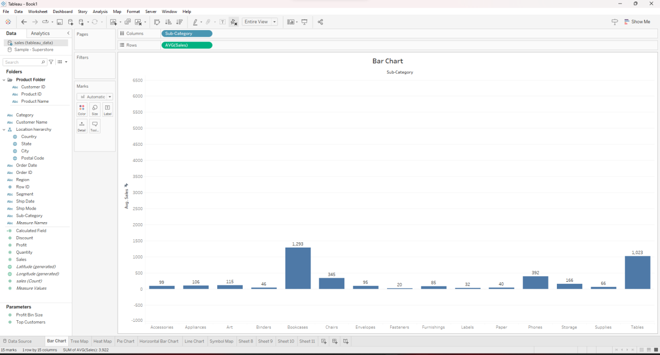

1. Tree Map

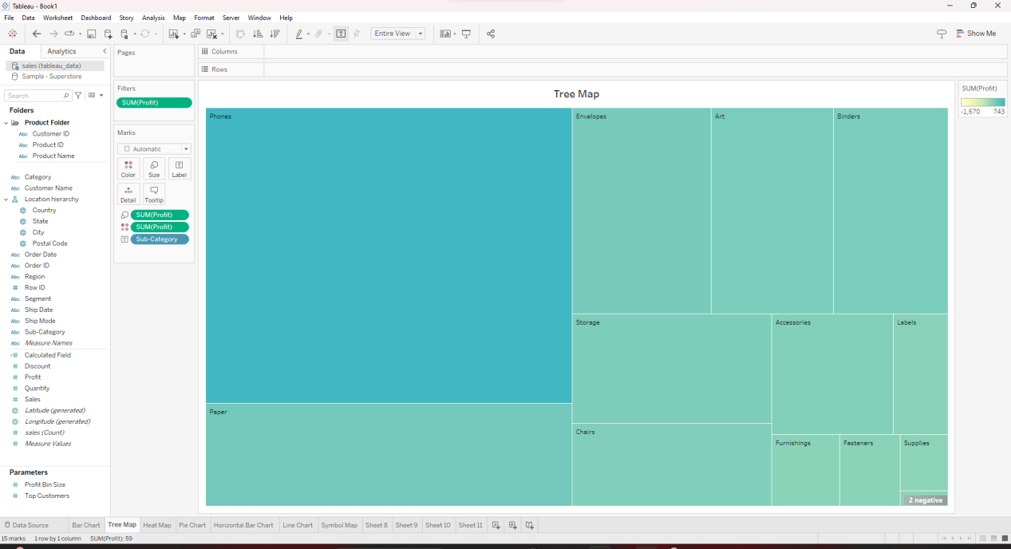

1. Heat Map

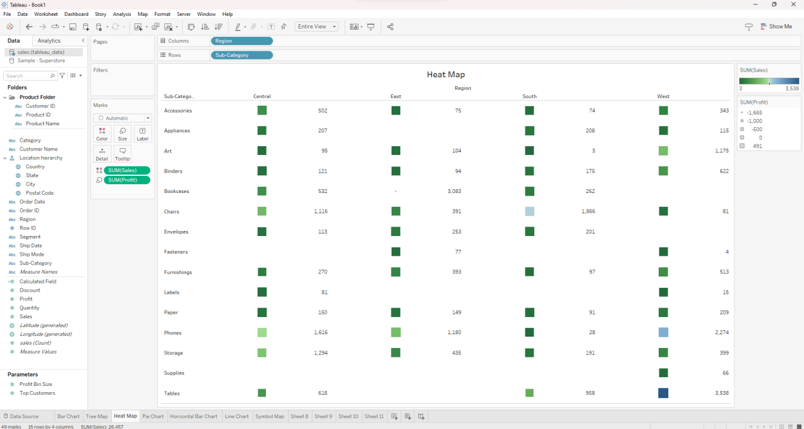

1. Pie Chart

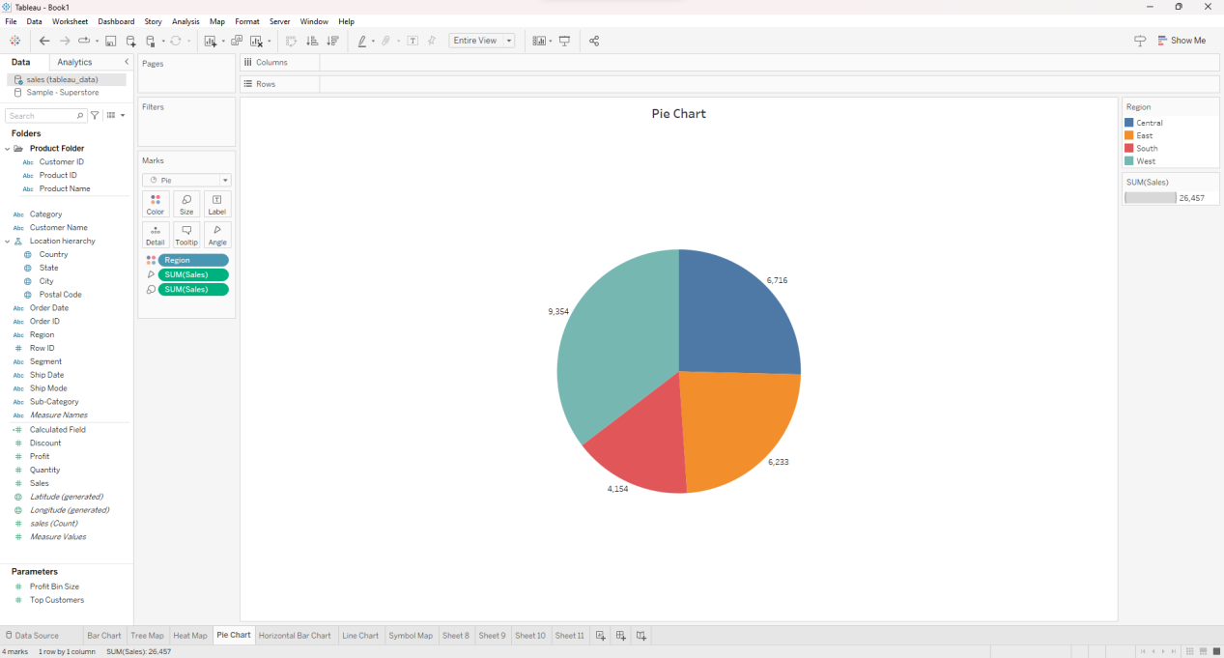

1. Horizontal Bar Chart

